1.Draw a UML diagram for hotel reservation system. In a hotel reservation system, a
customer can make online booking for a hotel, by specifying the accommodation
requirements such as type of room (AC/Non-AC, One bed/two bed), total no of rooms,
duration of stay. The system selects a suitable hotel as per customer’s requirements. If
a hotel is found then the availability of rooms in that hotel is checked. The charges are
calculated for the selected requirement and these are acknowledged to the customer. If
the customer is satisfactory about the selection made by the system, then he confirms
the reservation.

AIM:
To design a UML diagram for a hotel reservation system, illustrating the interactions between customers, the system, and hotel management.
PROCEDURE:

- Identify Actors:
  - Customer: Makes online reservations.
  - Hotel System: Manages room availability and pricing.
  - Admin: Manages bookings and system settings.
- Define Use Cases:
  - Search for available hotels.
  - Select room type and duration.
  - Check room availability.
  - Calculate total charges.
  - Confirm reservation.
- Relationships:
  - Customers interact with the hotel system.
  - Admin manages bookings and system data.
- Choose CASE Tool:
  - Use tools like StarUML or Lucidchart.
Create Diagrams:
- Use Case Diagram: Shows booking interactions.
- Class Diagram: Represents system components.
- Sequence Diagram: Outlines step-by-step booking process.

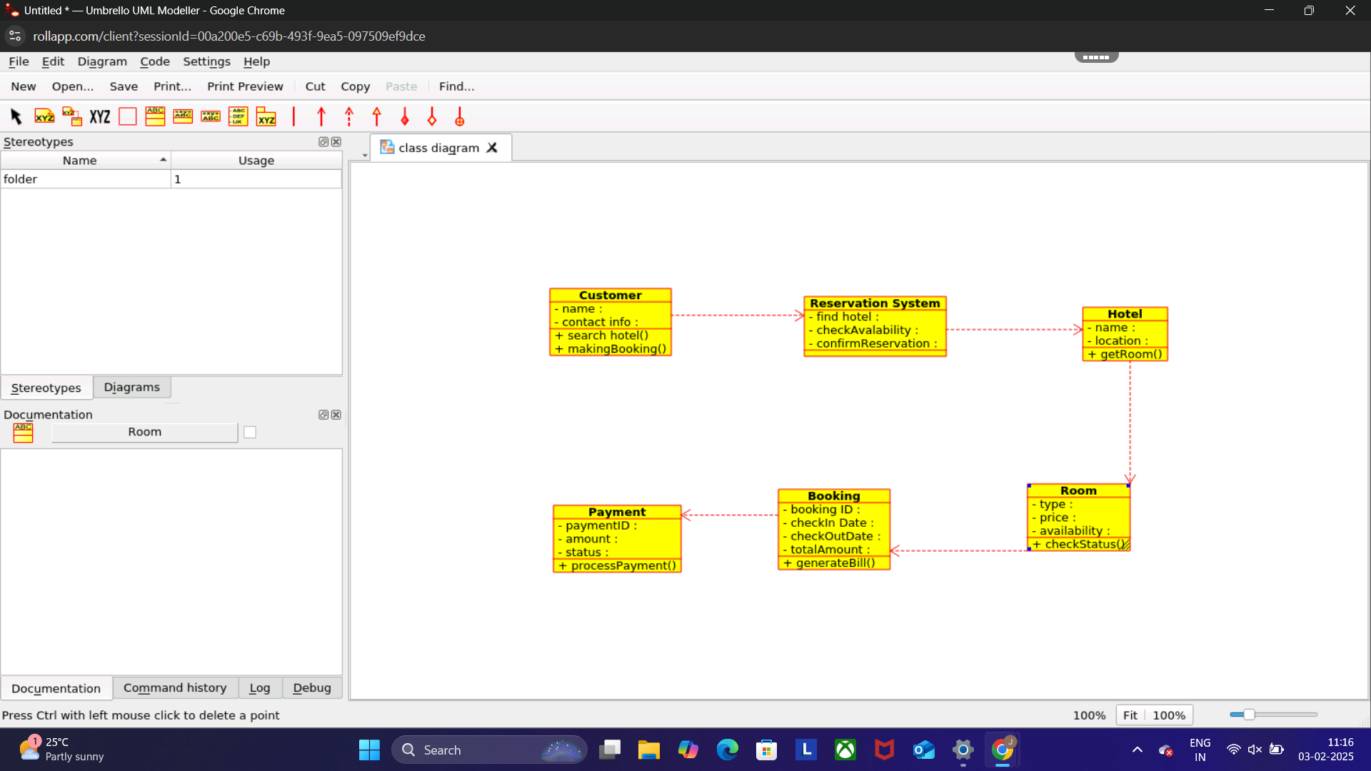

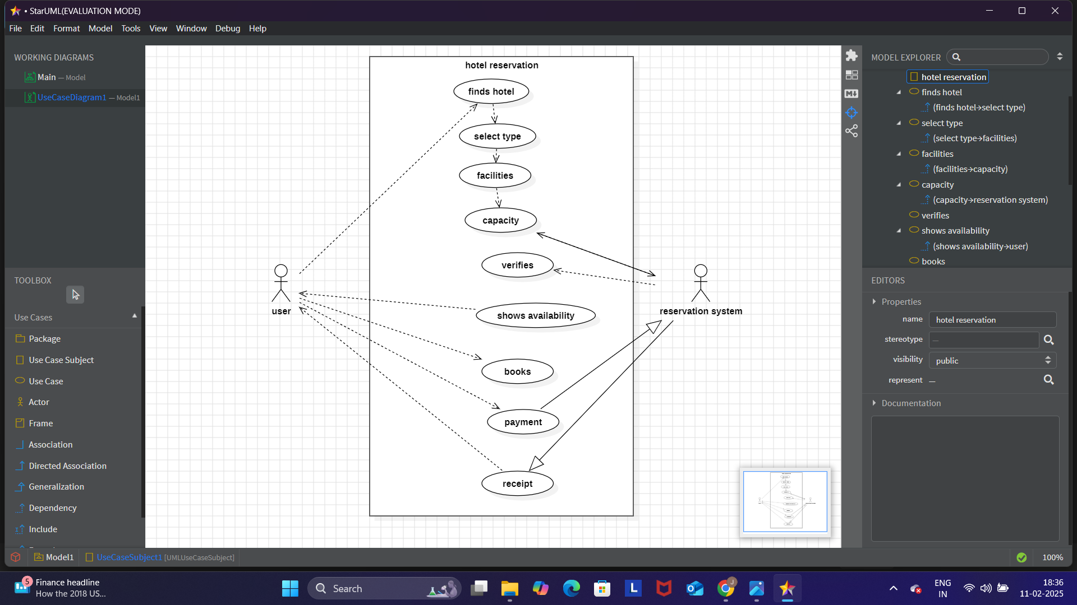
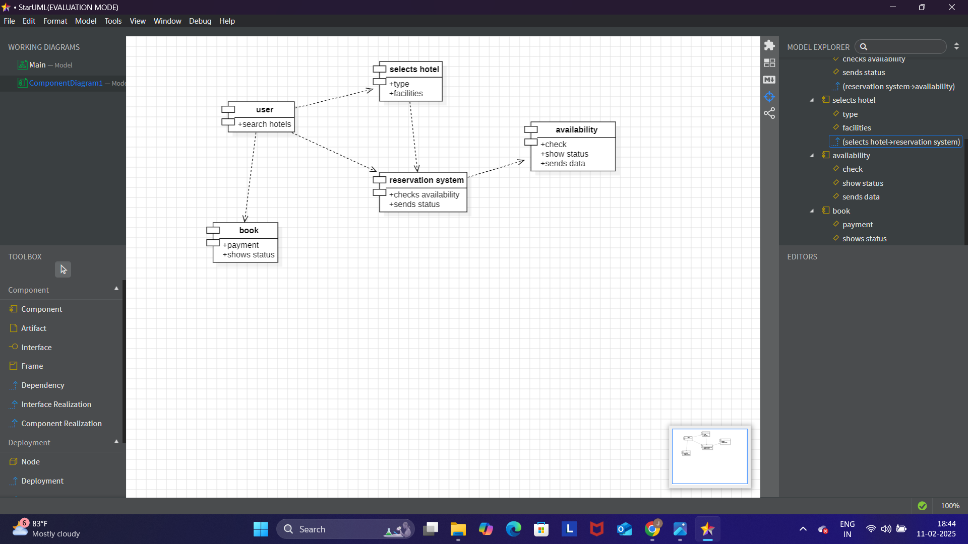

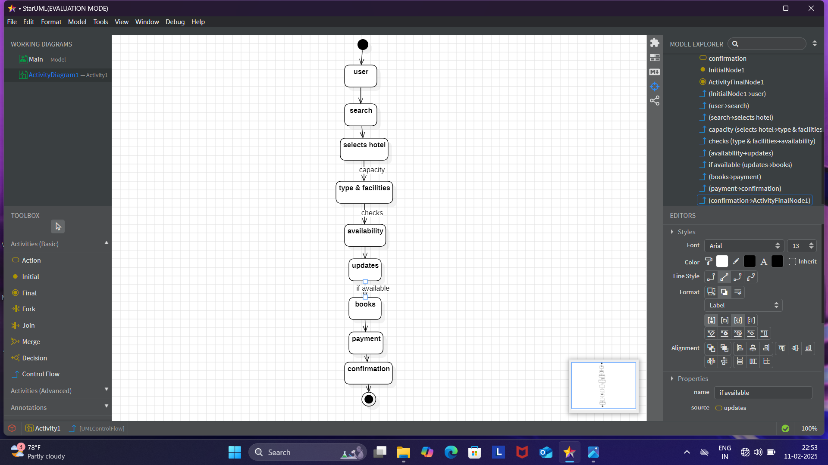
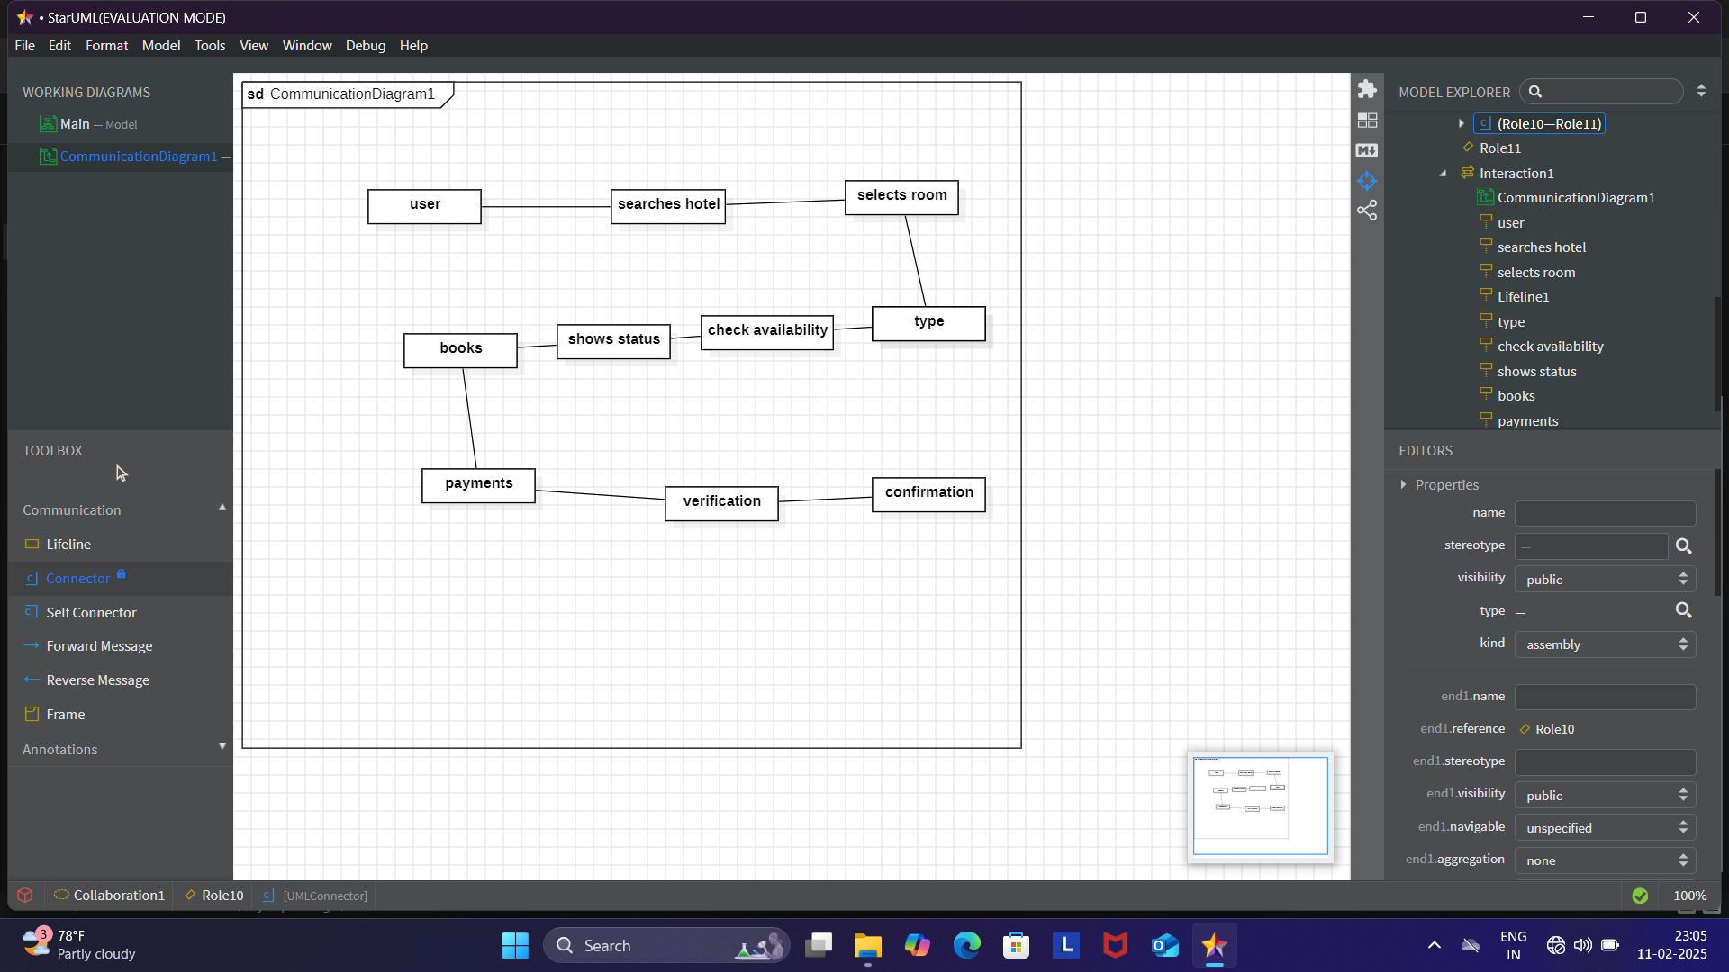

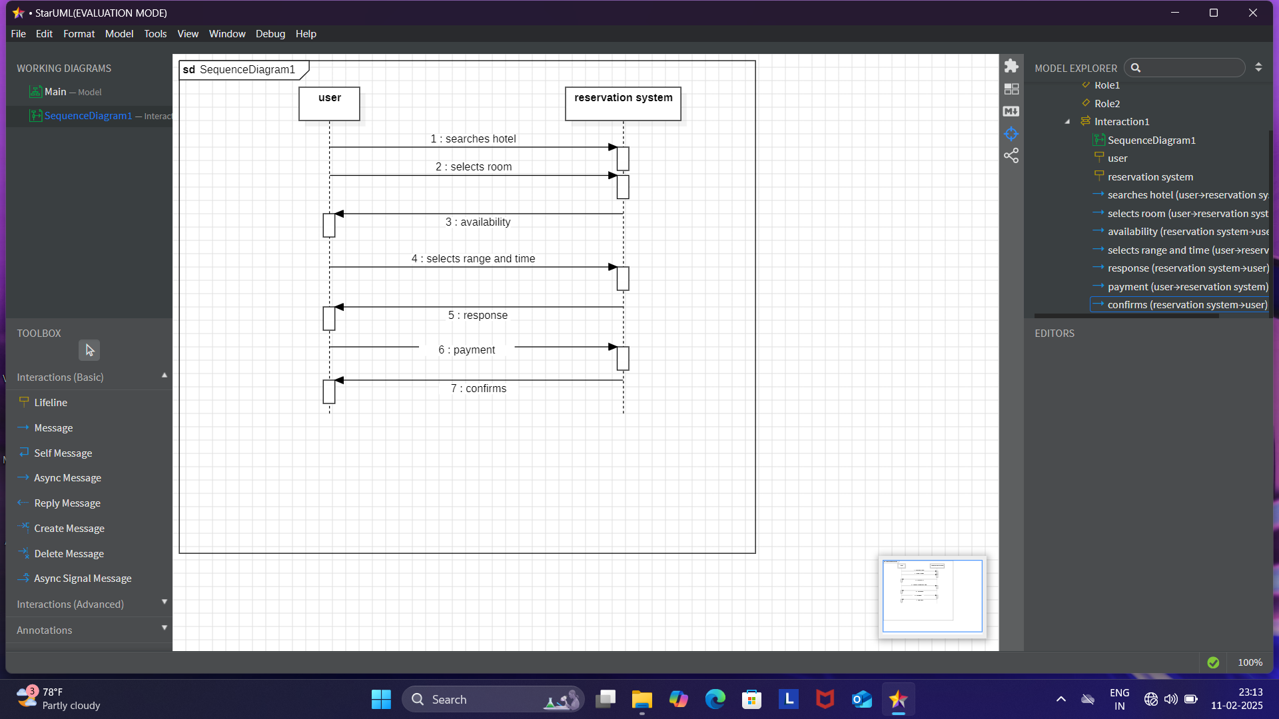
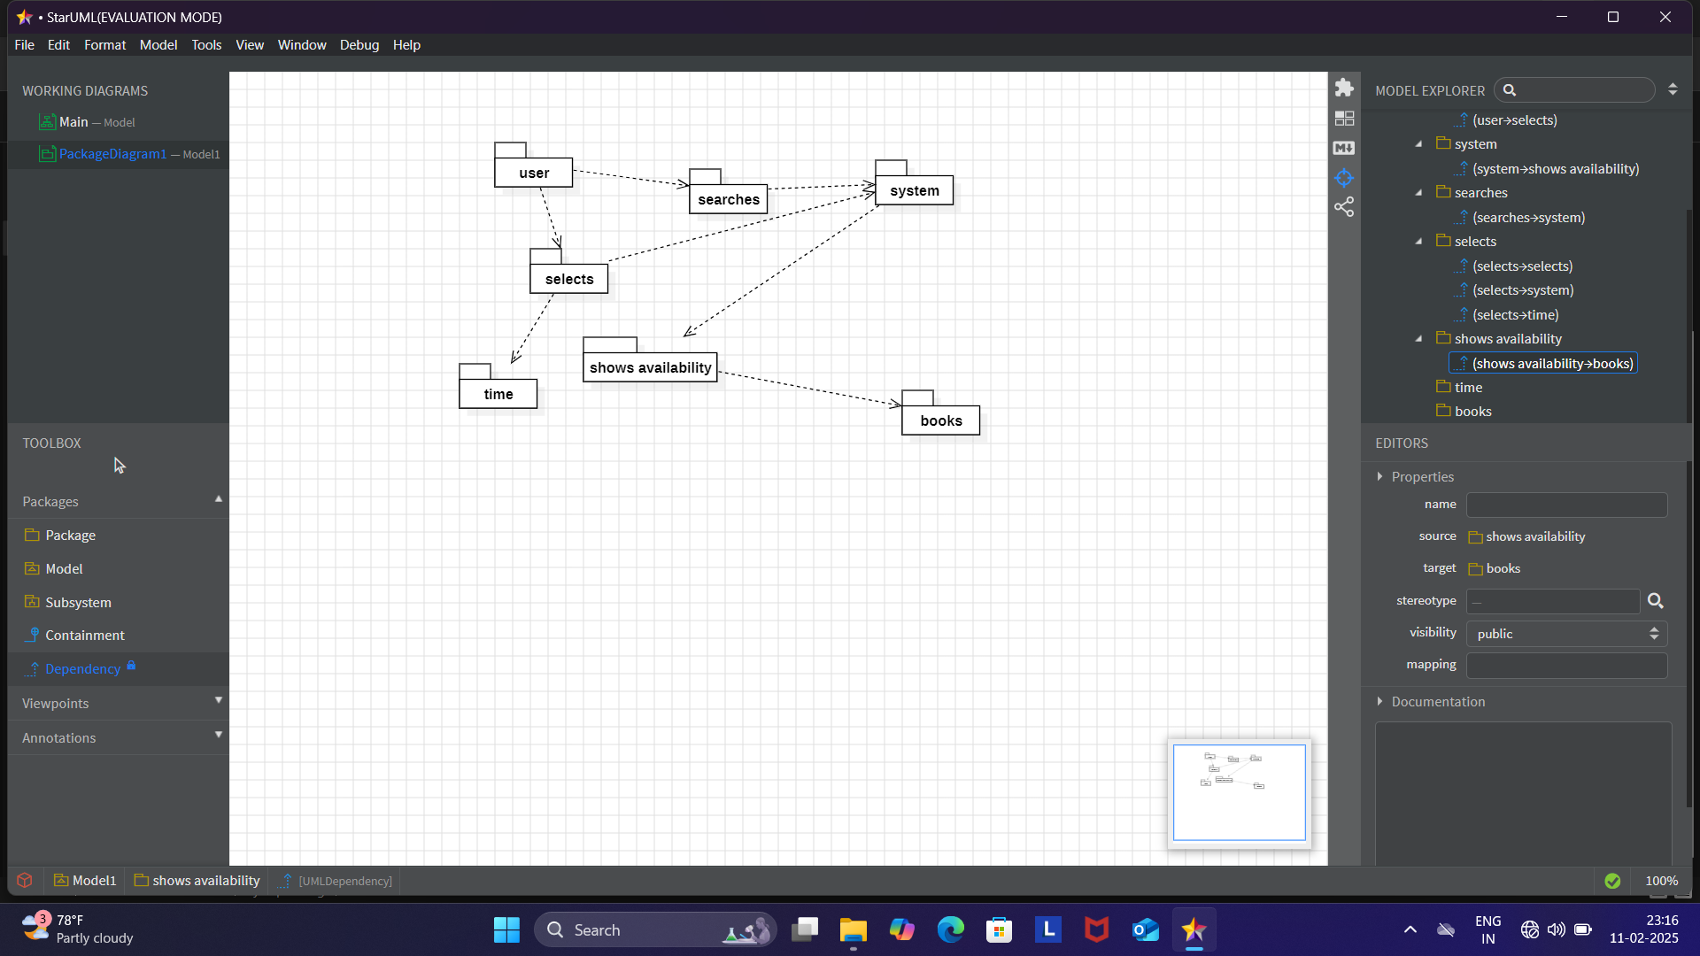

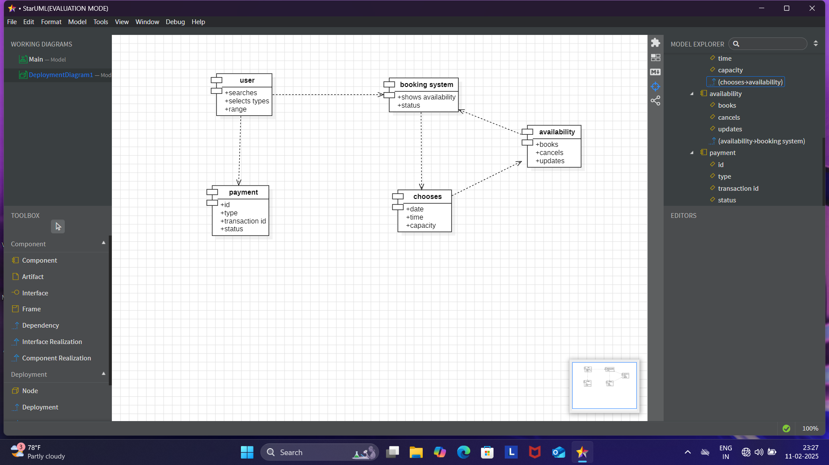
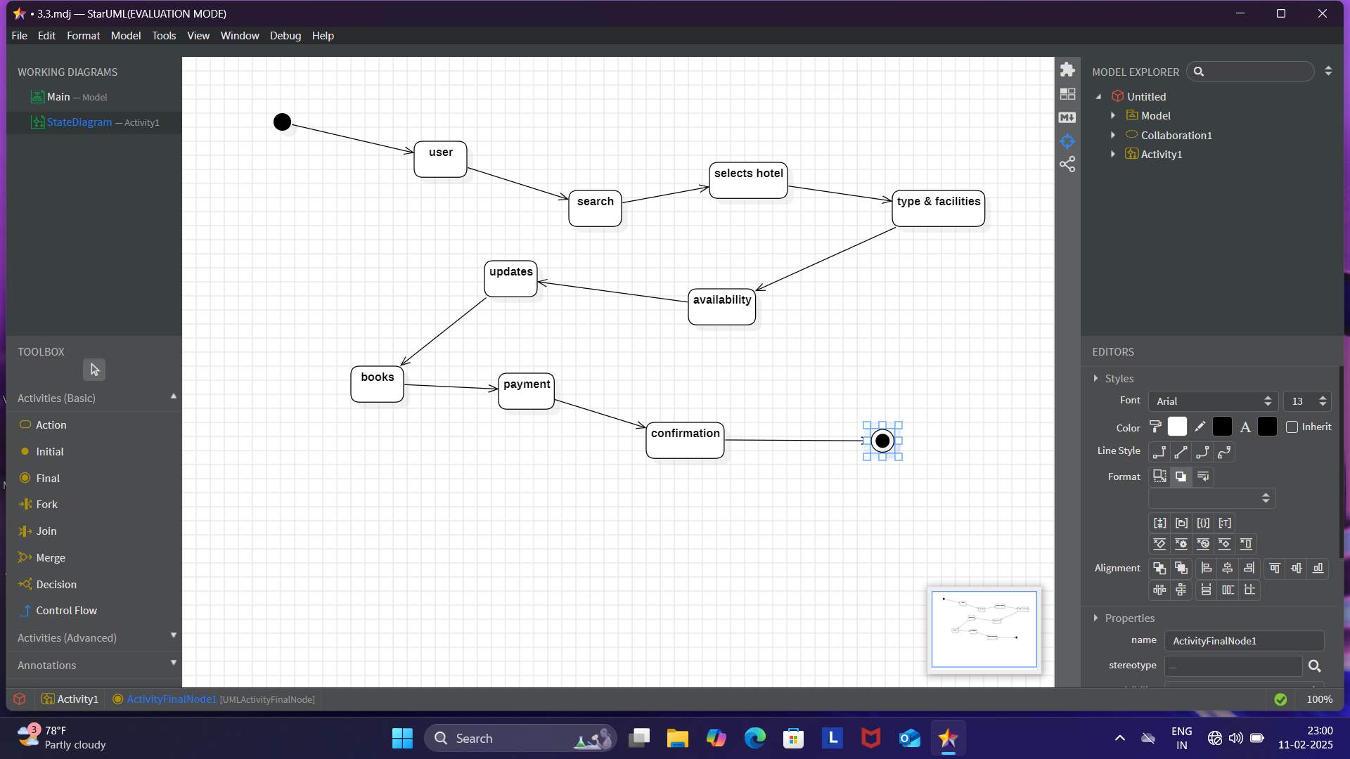

RESULT :

The UML diagram visualizes the hotel booking process, aiding development and analysis.

